**Global urban afforestation cools surface up to 1 °C from 2000 to 2015**

**Jiacheng Zhao1, Xiang Zhao1,*, Shunlin Liang2, Tao Zhou3,4, Ping Liu5, and Donghai Wu6,\***

1State Key Laboratory of Remote Sensing Science, Jointly Sponsored by Beijing Normal University and Institute of Remote Sensing and Digital Earth of Chinese Academy of Sciences, Faculty of Geographical Science, Beijing Normal University, Beijing 100875, China

2Department of Geographical Sciences, University of Maryland, College Park, MD 20742, USA

3Key Laboratory of Environmental Change and Natural Disaster of Ministry of Education, Academy of Disaster Reduction and Emergency Management, Faculty of Geographical Science, Beijing Normal University, Beijing 100875, China

4State Key Laboratory of Earth Surface Processes and Resource Ecology, Beijing Normal University, Beijing 100875, China

5College of Data Science, Taiyuan University of Technology, Taiyuan, Shanxi 030024, China

6Department of Ecology and Evolutionary Biology, Cornell University, Ithaca, NY 14853, USA

*Corresponding authors: zhaoxiang@bnu.edu.cn (X. Zhao); dw623@cornell.edu (D. Wu)

# Abstract

Tree planting is a prevalent option to mitigate urban heat. However, a global quantitative assessment of the cooling benefits from urban afforestation is still lacking. Here we use a series of 30-m resolution Landsat-based dataset to estimate how much cooling benefits was yielded from the combined effects of urban tree cooling efficiency (TCE, surface cooling benefits from 1% increase of urban tree cover) and tree cover increases across 516 large cities during 2000-2015. Urban TCE shows high spatial heterogeneity across the big cities, which mainly depends on nonlinear and hierarchical relations with annual precipitation and latitudes, respectively. During the study period, significant afforestation (total tree cover increase > 5%) occurred in 45% of the cities and on average yielded an annual surface temperature cooling of 1 °C. The most beneficial cities usually attribute to more tree cover increase and/or higher TCE with relative dry climates. In addition, under the future climate scenario of limiting global warming to 2 °C (SSP126), we predicted that the extra cooling benefits from on-going urban afforestation remain sustainable in the next 15 years (2015-2030).

# Introduction

Drastically urban expansion to meet large requirements of worldwide population explosions has as well caused environmental problems1,2. Massive increases in impervious materials change the surface energy budget, which enhancing the influences of urban heat islands (UHIs)3. As a result, warmer temperature chronically exerts heat stress on urban ecosystems and exacerbates morbidity/mortality risk interactively with heatwaves4-6. Currently, one-third of the world’s population is exposed to lethal heat7 and the situation is expected to worsen in the coming decades along with ongoing global warming7,8. Therefore, mitigating urban heat has become a fundamental issue that must be addressed in future urban planning.

Afforestation is considered one of the most prevalent adaptations to deteriorating urban climates. In past decades, tree planting campaigns such as the “Million Tree Initiative” and “large-scale urban afforestation programs” have been launched globally to increase overall sustainability9,10. Evidenced by remotely sensed observations, many cities are indeed experiencing a phenomenon of “green recovery”11. However, how much cooling has been yield from urban afforestation is not evaluated yet on a global scale. A key aspect of trees’ cooling effects is tree cooling efficiency (TCE), defined as the temperature reduction with 1% tree cover increase12,13. TCE varies a lot across cities because of multiple biophysical processes. In wet regions, high humidity can reduce the water potential between leaf and air, leading to a suppressed tree transpiration rate and thus lower TCE14. While in hot and dry climates, higher TCE could be expected due to typically higher plant-to-atmosphere temperature and water gradient, both of which increase trees’ transpiration demand15. Since trees, especially those coniferous trees in boreal zones, are generally dark and have lower albedo to absorb more energy, TCE is also offset by albedo warming16,17. Because of these trade-offs, TCE in cities located in different regions should be treated differently. Nevertheless, the global patterns of TCE remain unknown.

In this study, by using high-resolution remote sensing datasets, we first generated TCE for 516 global large cities with population more than half a million. Through a non-linear modelling technique, we established a global relationship between TCE and mean annual precipitation (MAP). Then we leveraged TCE and tree cover changes to estimate the cooling benefits from urban afforestation during 2000–2015. Based on climatic scenarios simulated by CMIP6 earth system models, we further predicted the cooling yield from sustained afforestation up to 2030 regarding the current planting scale.

# Results

## Climate-linked hierarchical TCE

To quantify the cooling benefits from urban afforestation, we first calculated daytime TCE for 516 global large cities (Fig. 1a). TCE mostly ranges from 0 to 0.2 °C/% with a global mean of 0.16 ± 0.13 °C/% (Supplementary Fig. 1a), indicating that urban trees generally cool the surface down in the daytime. However, it shows a substantial spatial heterogeneity. For example, TCE in the arid western United States (0.28 °C/%) could be more than two times higher than that in the humid east (0.12 °C/%). Likewise, other cities that experience dry climates such as those located in Western Asia, Southern Asia and northern China typically have a TCE larger than 0.2 °C/%. The soaring TCE in cities with MAP less than 500 mm (Fig. 1b) is related to the oasis effect prevalent in arid regions that plants, if well irrigated, can transpire a large amount of water to provide significantly cooling18,19. For regions with similar precipitation, TCE was observed latitudinal transitions such as that existed around 40° N in the eastern of United States and 50° N in Europe (Fig. 1a). More than 70% of TCE is less than 0.1 °C/% for cities located higher than 50° N. These results explicitly favour a climate-regulated TCE.

Accordingly, we established a nested allometric relationship between TCE and MAP across four latitudinal transects, namely 0°–20° N/S, 20°–40° N/S, 40°–50° N/S, and > 50° N/S (Fig. 1b). The model characterizes TCE as a hierarchical structure that suggests TCE in cities near the equator could be from 0.04 to 0.52 °C/% stronger than that in higher latitudes, depending on different wet conditions. Thus, it helps explain why larger TCE even occurs in more humid Southeast Asian cities (0.14 °C/%) than relatively dry Japanese cities (0.11 °C/%). As is known for natural forests17,20, these latitudinal hierarchies of urban trees are intrinsic to the competing effect of transpirative cooling and albedo warming (Supplementary Fig. 2). Trees in tropical cities maintain the maximal change of latent heat (∆LE, Supplementary Fig. 2a) and daytime energy residual (∆E, Supplementary Fig. 2c) to provide cooling. Yet as the latitude rises, they are damped both by decreased photosynthetically active radiation and increased albedo warming. In cities higher than 50° N, almost all latent heat was offset by the energy absorbed, resulting in minor cooling effects. Meanwhile, these biophysical responses are suppressed by increased humidity, further supporting the allometric TCE–MAP relationship.

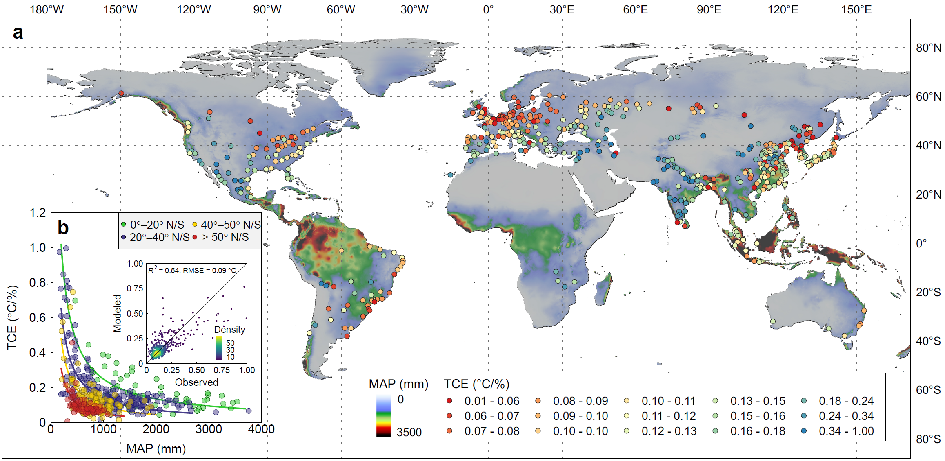

**Fig. 1** TCE of global cities. **a,** TCE for 516 global large cities with a population greater than half a million. Higher TCE values suggest more surface cooling benefits in a 30 × 30 urban pixel for a 1% increase in urban tree cover. The base map is the downscaled WorldClim MAP. **b,** A hierarchical model of global TCE. Each point represents the TCE in a specific city. The latitudinal hierarchies (indicated by points with a different colour) for four latitudinal transects i.e., 0°–20° N/S, 20°–40° N/S, 40°–50° N/S, and > 50° N/S, are nested in the allometric TCE-MAP relationship. The curves are the established hierarchical model corresponding to latitudinal transects. The inset figure shows the performance of the model (*R*2 = 0.54, RMSE = 0.09 °C/%).

## 1 °C surface cooling from urban afforestation

By comparing a global Landsat-based tree canopy cover data21 in 2000 and 2015, we found that urban afforestation was taken place in more than 90% cities with a global averaged tree cover increase of 5 ± 4% (Fig. 2). Significant afforestation that larger than the global mean (5% tree cover increase) occurred in 45% of these cities mainly clustered in Europe showing the largest increase (9.6%), followed by eastern North America (7.2%), North China (6.4%) and South Asia (6.3%). These fast changes can be mainly related to large-scale urban afforestation programs. For example, many tree programs were implemented in London to add and improve greenery22. Likewise, Beijing launched several times’ greenbelts plantation and the plain afforestation project that help plant a gross of about 100 million trees23,24. In contrast, less than 10% cities mainly located in South China and Southeast Asia had undergone deforestation with an averaged tree cover decrease of 2%.

The surface cooling benefits from such global urban afforestation yield a mean of 0.7 ± 0.4 °C (Supplementary Fig. 1b, Fig. 3), whereas the cooling achieved in cities with significant afforestation (> 5% tree cover increase) was up to 1 °C. Some of the extreme cases including Dnipro (12%, Ukraine), Minneapolis (12%, the United States) and Paris (9%, France) was approaching (even more than) 1.5 °C. Conversely, cities with deforestation on average resulted in 0.2 °C urban warming. On the city scale, unlike evenly distributed in cities such as Moscow (Fig. 3c) and Beijing (Fig. 3d), the increase of urban trees associated with their cooling benefits exhibit substantial intra-urban variation in many cities such as Detroit (Fig. 3a), Lusaka (Fig. 3j), and Melbourne (Fig. 3l). Despite an overall cooling of more than 1°C achieved, the eastern parts of Detroit and northwest Melbourne are barely covered by trees, thus suffering from apparent surface heat stress.

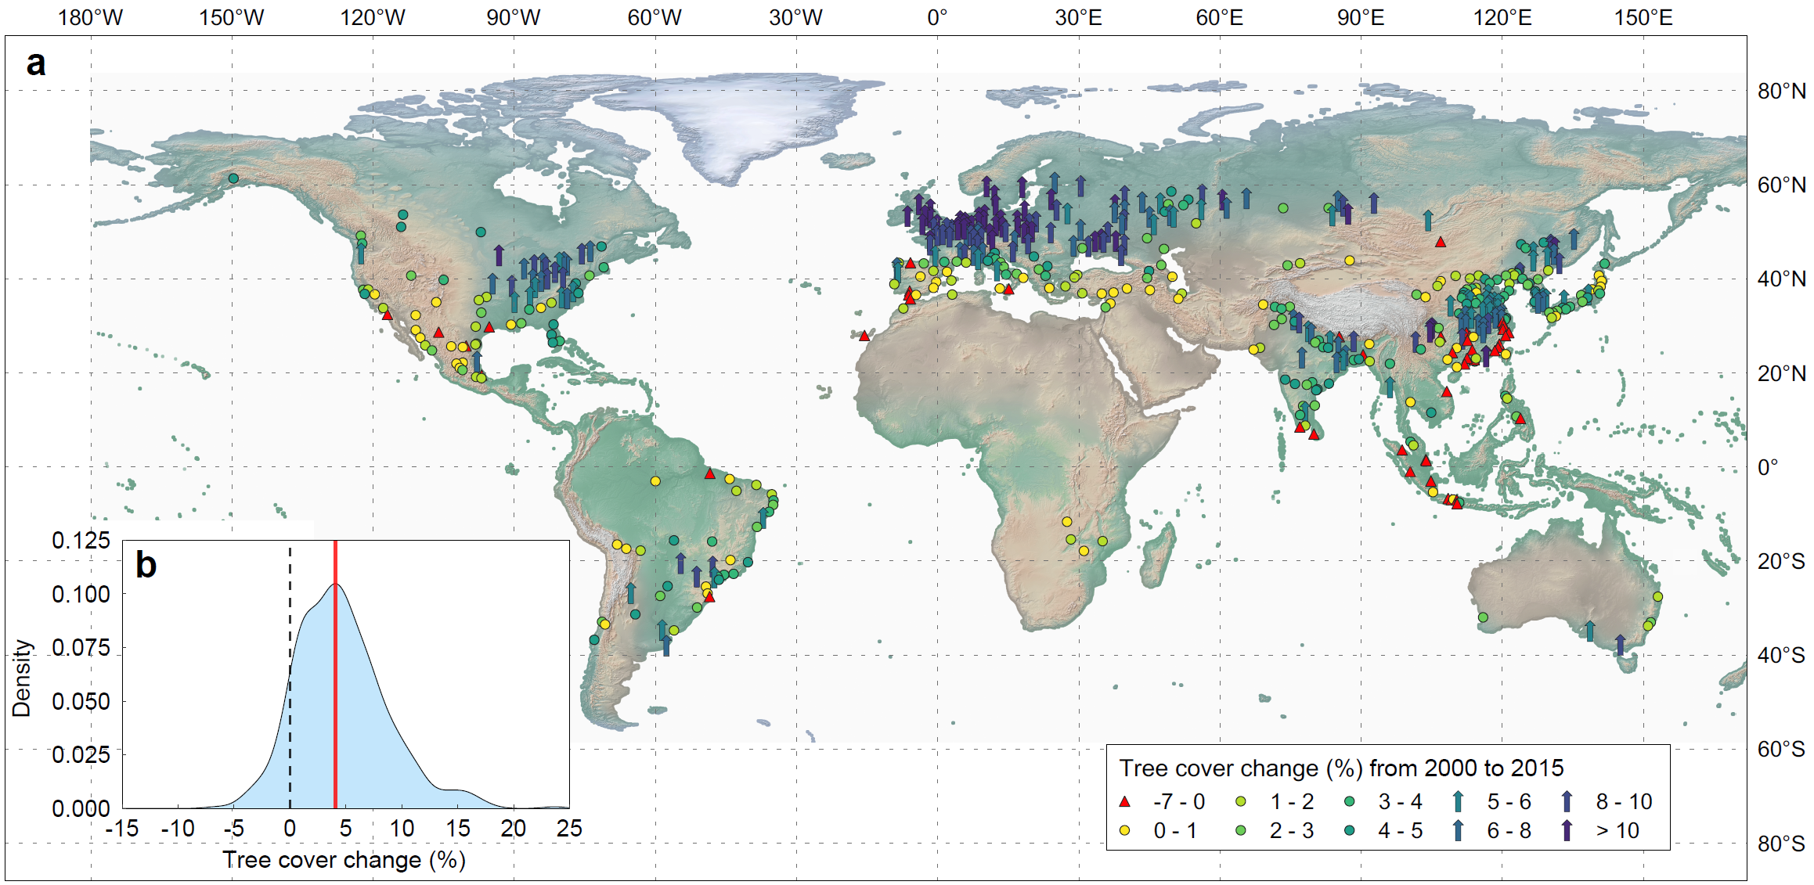

**Fig. 2** Tree cover change from 2000 to 2015. **a,** Spatial patterns of tree cover change for 516 global large cities with a population greater than half a million. Positive values (indicated by circles and upward arrows) represent urban afforestation while negative values (indicated by red triangles) represent urban deforestation. An upward arrow indicates the city with tree cover increase higher than 5%. **b,** Probability density of the tree cover change. The maximum probability density (solid red line) achieves at 4% tree cover change. A global mean (± standard deviation) change is 5 ± 4%.

The cooling from urban afforestation results from planting scale combined with local TCE (see methods). Despite large differences in the tree cover increase between cities in Europe (9 ± 4%) and Northern China (4 ± 2%) (Fig. 2), the tree cooling achieved in these regions is comparable e.g., 0.9 °C in Moscow (Fig. 3c) versus 1.2 °C in Beijing (Fig. 3d). By comparing Japanese and north Chinese cities with similar tree cover increases (Fig. 2), we observed a pronounced discrepancy in their cooling effects (Fig. 3, Fig. 3d-e). These results highlight the importance of climate-regulated TCE in combating urban heat and suggest planting in cities under wet climates and/or at high latitudes might be less efficient in cooling surface down. Although a simulation of climate models has claimed this viewpoint25, our observation-based modelling results empirically explain the minor contribution of transpirative cooling in wet climates because of low TCE (Fig. 1).

## Sustainable cooling with urban afforestation and climate change

By assuming a same tree cover increase as that from 2000 to 2015, we used future climate projections to estimate the potential cooling benefits from urban afforestation for the next 15 years (2015–2030). According to nine global climate models under the Shared Socio-economic Pathways (SSPs) 126, MAP only shows discernable changes in South Asia (+150 mm), South America (-130 mm) and Southeast Asia (-170 mm) while that in other continents suggests minor variations (Fig. 4b, Supplementary Fig. 4). These are equivalent to decreasing the averaged cooling benefits in Europe (-0.03 °C), South Asia (-0.06 °C), East Asia (-0.06 °C) and North America (-0.03 °C) but increasing in South America (+0.06 °C) and Southeast Asia (+0.003 °C) (Fig. 3a). Even under higher carbon emission scenarios, these minor changes are not more than 0.1 °C (e.g., 0.09 °C decrease for South Asian cities under SSPs 585, Supplementary Table 1). Thus, urban afforestation at the current planting scale, at least in a short-term future, could achieved similar cooling benefits as in the past 15 years. In addition, as more severe

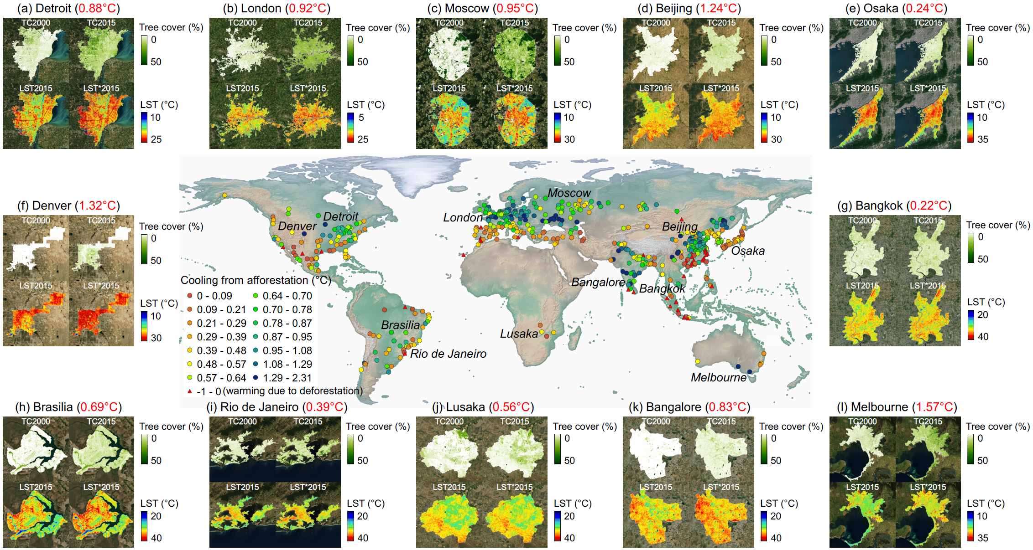

**Fig. 3** Cooling benefits from urban afforestation. The main plot gives the cooling benefits from urban afforestation from 2000 to 2015 for 516 global large cities. The triangular symbols in red denote urban warming due to deforestation. The background is a world shaded relief map that integrates land topography and natural environments (green for humid lowlands and brown for arid lowlands) provided by Natural Earth. The subplots (a-l) show the spatial patterns of tree cover increase and LST for 12 typical large cities across continents. TC2000 and TC2015 denote the tree cover in 2000 and 2015, respectively. LST2015 denotes the annual LST composite in 2015 and LST*2015 denotes the annual LST estimation in 2015 without the afforestation. The red number in each bracket indicates the mean cooling benefits for the city.

heatwaves are expected in South Asia and South America8, the cooling effects in these two regions, especially those in coastal cities of northeast South America, are presumably higher than our estimation because extreme heat simulates trees’ transpiration to provide more cooling12.

# Discussion

Urban afforestation is vigorously growing in global cities since the late 20th century24. Our observation-based results indicate that such afforestation, especially large-scale ones, substantially cool the daytime surface down in many cities experiencing relatively dry climates with high TCE. Conversely, little cooling benefits were yielded resulting from negligible afforestation and suppressed TCE. Planting trees in humid cities has been suggested less efficient in alleviating urban heat25,26. However, the claims were mainly drawn from reducing the UHI intensity, namely the temperature difference (∆*T*) between the urban and its surroundings. The wide use of ∆*T* is controversial because it strongly changes with the surface type of suburbs and a lower (even negative) ∆*T* does not necessarily imply the city does not have heat-related problems27. In contrast, the high-resolution TCE performed on fine urban grids in this study could be an “absolute” indicator describing how much surface temperature could be reduced by urban trees in different climates and thus more relevant to urban heat mitigation. It is worth noting that although largely suppressed by humidity, TCE in quite a few tropical cities is still higher than those in high latitudes (Fig. 1). This implies that cooling tropical cities by urban afforestation could be even easier than cooling high-latitude cities down, given the success of the cooling achieved in Europe. The 0.8 °C cooling

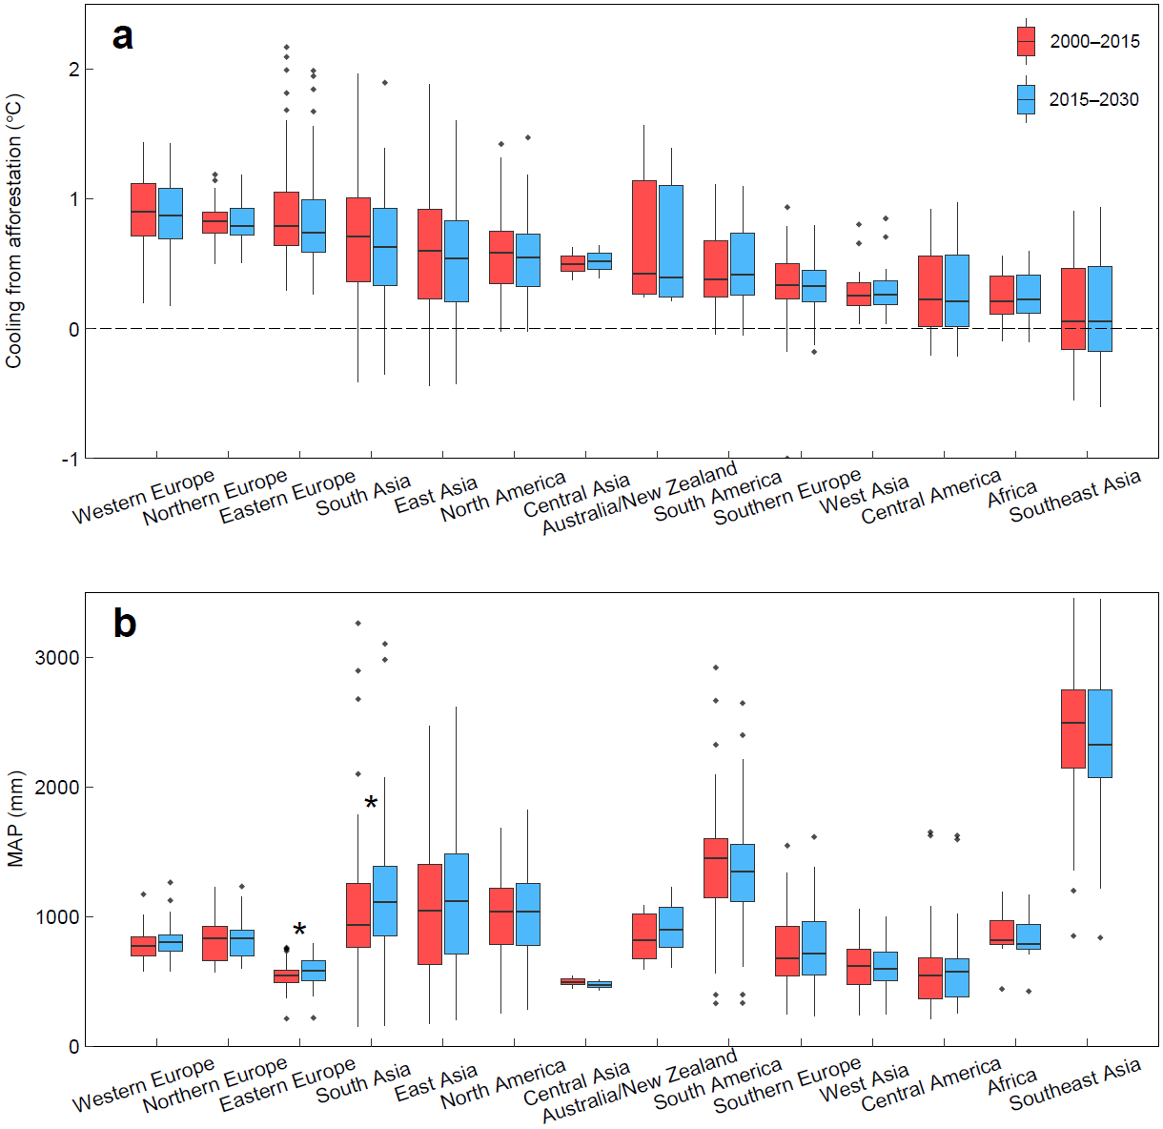

**Fig. 4** Predictions of the cooling benefits from urban afforestation in next 15 years. **a,** Comparison of the cooling benefits from urban afforestation in 2000–2015 (boxes with solid lines) and 2015–2030 (boxes with dashed lines) for European, South Asian, East Asian, North American, South American and Southeast Asian cities. **b,** Comparison of MAP in the two time periods. Each box contains the data among the first (25th percentile) and third quantile (75th percentile) with the black horizontal line indicating the median. The lines outside the box indicate 1.5 times the first/third quantile. The group with an asterisk exists a significant difference between the two epochs at the 0.05 level.

from 4% tree cover increase in Phnom Penh (Fig. 3g) could be such an example and precursor of “planting to cool” in humid and hot Southeast Asian cities.

Afforestation in boreal zones is commonly believed to have a local warming effect16,17,20, which is opposite to the cooling observed in high-latitude cities. This discrepancy could be mainly due to the different context between natural lands and urban areas. Converting grasslands or bare lands to forests in boreal zones can raise temperature because evapotranspiration (ET) cooling is entirely offset by strong albedo warming. Nevertheless, replacing impervious surfaces (e.g., buildings and roads) in a typical urban area with trees hardly produces warming effects since the former absorbs more energy while vastly diminishing the evaporation rate. Meanwhile, buildings also release anthropogenic heat to enlarge their warming effects. Thus, even in the latitudes higher than 50° N, urban trees’ temperature is still lower than other artificial elements, making urban afforestation represent a cooling effect.

Our study indicated scale-dependent heterogeneity of the cooling benefits from urban afforestation. At the global scale, the large discrepancy in planting scale and TCE combine to determine the distinctive cooling patterns across continents from nearly zero in Southeast Asia to approaching 1 °C in Western Europe (Fig. 4). Despite mostly low cooling benefits observed in some regions such as South America, nine of fourteen regions analyzed exist cases that show more than 1 °C averaged city cooling (Fig. 4). At the mesoscale, however, the appreciable cooling in many cities show substantial heterogeneity because of unbalanced tree planting. Such uneven cooling within cities could largely result from the mismatch between municipal-level planting goals aiming directly at increasing overall tree cover versus individual or community-level tree demands28. Urban trees in public ownership (for example, in China) are more likely to equitably increased via afforestation programs led by municipal departments. Yet for many cities in the United States, trees are distributed or sometimes given away29. Those residents with low income and education level are evidenced show fewer concerns and participants in tree planting28, leading to a large discrepancy in tree cover increase across communities.

Trees are well known as ’natural capital’ to provide various ecosystem services and landscape merits in urban areas30. However, tree planting must be carefully implemented31. Before plantation, urban planners should have foresight how well trees can perform their functionalities and balance the desired outcomes and resources invested. Despite a sustainable cooling effect was predicted in the next few decades along with ongoing urban afforestation, achieving the desired environmental benefits would still be challenging. Firstly, urban trees’ cooling effects, especially those in arid or semi-arid cities, come at the expense of intensive irrigation. Continually planting in these cities could often be accompanied by urban runoff reduction and more water consumption32. The use of drought-tolerant tree species inevitably incurs a decreased transpirative cooling owing to the mechanisms of water retaining. Secondly, urban trees’ future planting largely depends on urban planning schemes and varies in different land-use and land-cover scenarios. With more sophisticated urban management, more trees can sometimes be a burden due to higher maintenance/monitoring costs of post-planting, which in turn incurs tree mortality33. Furthermore, trees’ survival may increasingly be vulnerable to climate change as future warming and drought stress34,35. Thirdly, the urban thermal environment also benefits from optimizing trees’ spatial configuration36. Other factors including street canyon geometry and growing conditions alter the microclimate (e.g., radiation, accessibility of soil water) to change trees’ performance37-39.

This study is the first fine-resolution thermal assessment of urban afforestation conducted in worldwide cities. Our global analysis estimated that during the period 2000–2015, the daytime surface cooling from urban afforestation was an average of 0.7 °C while up to 1 °C for cities with large planting scale. Nevertheless, greater planting efforts were taken for cities in humid climates and/or high latitudes to achieve equivalent cooling as in dry conditions. Future plantation should address the highlighted hierarchical nonlinearity between TCE and the background climate if trees are primarily planted for alleviating urban heat. With increasing heat stress from urbanization and global climate change, urban afforestation is a low-carbon and energy-efficient measure that buffer urbanized areas the aim of within 2 °C temperature boundary.

# Methods

## High-resolution tree canopy cover data

The Landsat-based global tree cover layers21 contain the percentage of horizontal ground at each 30-m pixel covered by woody vegetation greater than 5 meters in height. The dataset has been produced for four-year epochs i.e., 2000, 2005, 2010 and 2015. For each city, we calculated the tree cover change (TCC) for the period 2000–2015 as

$TCC=1/n(\sum_{i=1}^{n}{{TC}_{i}^{2015}}-\sum_{i=1}^{n}{{TC}_{i}^{2000}})$ (1)

where ${TC}_{i}^{2000}$ and ${TC}_{i}^{2015}$ are the tree cover for *i*th pixel in 2000 and 2015, respectively. Since the study highly focus on the cooling of urban trees, we only made calculation on urban pixels identified by the Moderate Resolution Imaging Spectroradiometer (MODIS) yearly land cover product (MCD12Q1) (same processing was also applied to the following steps).

## Precipitation data

The MAP for 2000–2015 was aggregated from the very high resolution (1-km) WorldClim historical monthly climate data40, which is downscaled from the version 4 of the CRU TS dataset41. The future precipitation data we used is the CMIP642 downscaled future climate projections. The monthly values of the dataset are first processed for nine global climate models and four SSPs (126, 245, 370 and 585) and then averaged over 20 year periods (2021–2040, 2041–2060, 2061–2080 and 2081–2100). We aggregated the monthly precipitation of 2021–2040 to represent the MAP for 2015–2030.

## Landsat-based surface parameters

We used the level-1 precision and terrain corrected Landsat 5/8 surface reflectance dataset provided by the United States Geological Survey (USGS) to estimate high-resolution surface parameters including LST, latent heat and albedo. The dataset has a 30-m spatial resolution and is the highest quality level-1 Landsat products which are radiometrically calibrated, orthorectified and atmospherically corrected. Scene cloud and cloud shadow detected by the CFMask algorithm43 were masked based on the quality assessment band.

We employed a single channel algorithm44 to retrieve LST from the Landsat thermal bands (band 6 for Landsat 5 and band 10 for Landsat 8). The processes are mainly converting at-sensor brightness temperature to LST with regarding the atmospheric influence. Surface emissivity is critical for LST retrieval. Thus, it is first spectrally adjusted from the ASTER global emissivity45 and then modified to account for vegetation phenology46. The atmospheric water vapour content used for calculating atmospheric parameters was extracted from the NCEP/NCAR reanalysis data, which has a 6-hour temporal resolution (00:00, 06:00, 12:00, and 18:00 UTC) and 2.5 degree spatial resolution47. The water vapour on each Landsat acquisition time was approximated by linearly interpolating the two closest water vapour values. We validated the retrieved LST using ground-based measurements from six surface radiation budget (SURFRAD) network stations. A detailed validation process can be found in the Ref46. The results show that the retrieved LST has a bias of +1.5°C (Supplementary Fig. 5).

We estimated the Landsat 5 broadband albedo in total shortwave ($α_{short}$) based on a conversion formulae given by Liang48

(2)

where $α_{1}$, $α_{3}$, $α_{4}$, $α_{5}$ and $α_{7}$ are the narrowband surface reflectance of Landsat 5 band 1, band 3, band 4, band 5 and band 7, respectively.

We transferred an improved MODIS global terrestrial evapotranspiration (ET) algorithm49 to Landsat sensors. The algorithm is based on the the Penman–Monteith (P–M) equation50 and the total daytime ET was partitioned into the evaporation from wet canopy surface, plant transpiration and soil evaporation. The biome properties look-up table for MODIS ET algorithm was used to parameterize the Landsat ET on the basis of the Copernicus global land cover layers with a spatial resolution of 100 m.

## Hierarchical TCE modelling and the cooling benefits from urban afforestation

TCE in this study is assumed invariant for a specific city during the study period (2000–2015) and defined as the LST reduction for 1% tree cover increase. For each city, we derived TCE from the slope of the robust regression51 between LST and tree canopy cover in 2010. In order to match the yearly tree cover data, all LST images covering the city were aggregated to gernerate annual LST composite. LST images in neighbouring years (i.e., 2009 and 2011) were also used to make sure the composite is aggregated from images covering not less than eight independent months. TCE has been reported to be regulated by the background climate, especially soil and atmospheric moisture15. Meanwhile, due to the competing biophysical effects (e.g., albedo and evapotranspiration), the influence of trees on local temperature weakens from the tropics to boreal zones17,52. These features characterize TCE a hierarchical structure nested in the climatic regulation, which should be taken into consideration in the modelling. Accordingly, we employed a allometric function (*y* = *axb*) to fit the relationship between TCE and MAP with the parameter a and b embedded in three latitudinal levels, namely low latitude (0°–20° S/N), medium latitude (20° S/N–50° S/N) and high latitude (> 50° S/N)

${TCE}_{ij}=\left(a+a_{j}\right)×P_{ij}^{b+b_{j}}+ε_{ij}$ (3)

where ${TCE}_{ij}$ and $P_{ij}$ denotes the TCE and MAP for *i*th city located at *j*th latitudinal level; $a$ and $b$ are fixed effects which characterize how precipitation generally affects TCE, whereas $a_{j}$ and $b_{j}$ represent high-level latitudinal effects added to the fixed effects that vary in latitudinal transects; $ε_{ij}$ is a vector of residuals. For each city, the cooling from urban tree planting is estimated by averaging each of pixel-level (30-m) cooling defined as

${COOLING}_{i}={TCE}_{i}×({TC}_{i}^{2015}-{TC}_{i}^{2000})$ (4)

where ${COOLING}_{i}$ denotes the tree cooling for *i*th pixel from 2000 to 2015.

## Estimation of future cooling from urban afforestation

By using the rate of city greening derived from the tree cover data for four consecutive epochs (2000, 2005, 2010 and 2015), we predicted the cooling of newly-increased trees in the next 15 years (2015–2030). The future precipitation projections for the new Shared Socio-economic Pathways (SSPs) in CMIP6 was considered.

## Biophysical mechanism

The transpirative cooling of trees is a thermodynamic process that evaporates water through leaves into the atmosphere, thus replacing sensible heat to latent heat53. Mathematically, it follows the surface energy balance equation

$R_{sw}\left(1-α\right)+L_{n}+Q_{ah}=H+LE+G$ (5)

where $R_{sw}$ is the incoming shortwave radiation, $α$ is the surface albedo, $L_{n}=L^{↓}-L^{↑}$ is the net longwave radiation composed of an upward longwave component $L^{↑}=\left(1-ε_{s}\right)ε_{a}σT_{a}^{4}+ε_{s}σT_{s}^{4}$ and a downward longwave component $L^{↓}=ε_{a}σT_{a}^{4}$, $Q_{ah}$ is the anthropogenic heat flux, $H$ is the sensible heat flux expressed as $ρc_{p}\frac{T_{s}-T_{a}}{r_{a}}$ where $ρ$ is the the mean air density, $c_{p}$ is the specific heat of dry air, $T_{s}$ and $T_{a}$ are the surface and air temperature, respectively, and $r_{a}$ is the aerodynamic resistance, $LE$ is the latent heat flux, and $G$ is the ground heat flux. Accordingly, Eq. 5 can be written as

$R_{sw}\left(1-α\right)+ε_{a}σT_{a}^{4}-\left(1-ε_{s}\right)ε_{a}σT_{a}^{4}-ε_{s}σT_{s}^{4}-ρc_{p}\frac{T_{s}-T_{a}}{r_{a}}-LE+Q_{ah}-G=0$ (6)

When planting trees on a typical urban grid (e.g., a 30 m 30 m pixel), the surface energy balance is changed by several terms like latent heat ($LE$), surface albedo ($α$) and roughness ()16. Such a perturbation could be expressed by differentiating Eq. 6 as

$$-R_{sw}∆α+σε_{s}T_{a}^{4}∆ε_{a}+σ\left(ε_{a}T_{a}^{4}-T_{s}^{4}\right)∆ε_{s}+4σε_{s}ε_{a}T_{a}^{3}∆T_{a}-4{σε}_{s}T_{s}^{3}∆T_{s}-$$

$\frac{ρc_{p}}{r_{a}}∆T_{s}+\frac{ρc_{p}}{r_{a}}∆T_{a}+\frac{ρc_{p}}{r_{a}^{2}}(T_{s}-T_{a})∆r_{a}-∆LE-∆G=0$ (7)

where $∆$ denotes a perturbation signal that represents the sensitivity of surface parameters to tree cover. By ignoring the minor terms such as the changes in $ε$ and $G$ (note that adding trees does not change the $Q_{ah}$, making $∆Q_{ah}=0$), we obtain a approximate expression of the sensitivity of surface temperature to tree cover ($∆T_{s}$, equivalent to TCE in this study)

$∆T_{s}≈\frac{1}{f_{s}}\left[-R_{sw}∆α+f_{a}∆T_{a}+\frac{ρc_{p}}{r_{a}^{2}}\left(T_{s}-T_{a}\right)∆r_{a}-∆LE\right]$ (8)

where $f_{s}=\frac{ρc_{p}}{r_{a}}+4{σε}_{s}T_{s}^{3}$ and $f_{a}=\frac{ρc_{p}}{r_{a}}+4σε_{s}ε_{a}T_{a}^{3}$ are energy redistribution factors representing the surface and air temperature sensitivity to one-unit radiative forcing54.

In such a process, $∆T_{s}$ can be regulated by the combined effect of (i) the sensitivity of latent heat ($∆LE$) that amplifies $∆T_{s}$, (ii) the sensitivity of albedo ($∆α$) that damps $∆T_{s}$ because trees are generally dark and have lower albedo, resulting in a negative $∆α$ and (iii) the sensitivity of roughness ($∆r_{a}$) that could either be positive (smoother) or negative (rougher), depending on the canopy geometry of trees planted and original surface structure. To further support the established TCE model, we further analyzed the $∆LE$, $∆α$, and daytime energy residual $∆E=-R_{sw}∆α-∆LE$ in different latitudinal transects and MAP bins.

# References

1. Foley, J. A. *et al.* Global consequences of land use. *science* **309**, 570-574 (2005).

2. Grimm, N. B. *et al.* Global change and the ecology of cities. *science* **319**, 756-760 (2008).

3. Voogt, J. A. & Oke, T. R. Thermal remote sensing of urban climates. *Remote sensing of environment* **86**, 370-384 (2003).

4. Patz, J. A., Campbell-Lendrum, D., Holloway, T. & Foley, J. A. Impact of regional climate change on human health. *Nature* **438**, 310-317 (2005).

5. Anderson, G. B. & Bell, M. L. Heat waves in the United States: mortality risk during heat waves and effect modification by heat wave characteristics in 43 US communities. *Environmental health perspectives* **119**, 210-218 (2011).

6. Zhao, L. *et al.* Interactions between urban heat islands and heat waves. *Environmental research letters* **13**, 034003 (2018).

7. Mora, C. *et al.* Global risk of deadly heat. *Nature climate change* **7**, 501-506 (2017).

8. Perkins-Kirkpatrick, S. & Lewis, S. Increasing trends in regional heatwaves. *Nature communications* **11**, 1-8 (2020).

9. Nilon, C. H. *et al.* Planning for the future of urban biodiversity: a global review of city-scale initiatives. *BioScience* **67**, 332-342 (2017).

10. *Protecting and developing the urban tree canopy a 135-city study* (City Policy Associates, Washington, D.C, 2008); https://www.usmayors.org

11. Liu, X. *et al.* High-spatiotemporal-resolution mapping of global urban change from 1985 to 2015. *Nature Sustainability*, 1-7 (2020).

12. Wang, C., Wang, Z.-H., Wang, C. & Myint, S. W. Environmental cooling provided by urban trees under extreme heat and cold waves in US cities. *Remote sensing of environment* **227**, 28-43 (2019).

13. Wang, J. *et al.* Significant effects of ecological context on urban trees’ cooling efficiency. *ISPRS Journal of Photogrammetry and Remote Sensing* **159**, 78-89 (2020).

14. Jim, C. Y. & Peng, L. L. Weather effect on thermal and energy performance of an extensive tropical green roof. *Urban Forestry & Urban Greening* **11**, 73-85 (2012).

15. Gunawardena, K., Wells, M. & Kershaw, T. Utilising green and bluespace to mitigate urban heat island intensity. *Science of the Total Environment* **584**, 1040-1055 (2017).

16. Lee, X. *et al.* Observed increase in local cooling effect of deforestation at higher latitudes. *Nature* **479**, 384-387 (2011).

17. Li, Y. *et al.* Local cooling and warming effects of forests based on satellite observations. *Nature communications* **6**, 1-8 (2015).

18. Taha, H., Akbari, H. & Rosenfeld, A. Heat island and oasis effects of vegetative canopies: micro-meteorological field-measurements. *Theoretical and Applied Climatology* **44**, 123-138 (1991).

19. Hao, X., Li, W. & Deng, H. The oasis effect and summer temperature rise in arid regions-case study in Tarim Basin. *Scientific reports* **6**, 1-9 (2016).

20. Bonan, G. B. Forests and climate change: forcings, feedbacks, and the climate benefits of forests. *science* **320**, 1444-1449 (2008).

21. Sexton, J. O. *et al.* Global, 30-m resolution continuous fields of tree cover: Landsat-based rescaling of MODIS vegetation continuous fields with lidar-based estimates of error. *International Journal of Digital Earth* **6**, 427-448 (2013).

22. *Previous green space and tree programmes* (Mayor of London, 2021); https://www.london.gov.uk/what-we-do/environment/parks-green-spaces-and-biodiversity/previous-green-space-and-tree-programmes

23. Yang, J. & Jinxing, Z. The failure and success of greenbelt program in Beijing. *Urban Forestry & Urban Greening* **6**, 287-296 (2007).

24. Yao, N. *et al.* Beijing’s 50 million new urban trees: Strategic governance for large-scale urban afforestation. *Urban Forestry & Urban Greening* **44**, 126392 (2019).

25. Zhao, L., Lee, X., Smith, R. B. & Oleson, K. Strong contributions of local background climate to urban heat islands. *Nature* **511**, 216-219 (2014).

26. Manoli, G. *et al.* Magnitude of urban heat islands largely explained by climate and population. *Nature* **573**, 55-60 (2019).

27. Martilli, A., Krayenhoff, E. S. & Nazarian, N. Is the urban heat island intensity relevant for heat mitigation studies? *Urban Climate* **31**, 100541 (2020).

28. Dawes, L. C., Adams, A. E., Escobedo, F. J. & Soto, J. R. Socioeconomic and ecological perceptions and barriers to urban tree distribution and reforestation programs. *Urban Ecosystems* **21**, 657-671 (2018).

29. Nguyen, V. D. *et al.* Branching out to residential lands: missions and strategies of five tree distribution programs in the US. *Urban Forestry & Urban Greening* **22**, 24-35 (2017).

30. Willis, K. J. & Petrokofsky, G. The natural capital of city trees. *Science* **356**, 374-376 (2017).

31. Holl, K. D. & Brancalion, P. H. Tree planting is not a simple solution. *Science* **368**, 580-581 (2020).

32. Feng, X. *et al.* Revegetation in China’s Loess Plateau is approaching sustainable water resource limits. *Nature Climate Change* **6**, 1019-1022 (2016).

33. Hilbert, D. R., Roman, L. A., Koeser, A. K., Vogt, J. & van Doorn, N. S. Urban tree mortality: a literature review. *Arboriculture & Urban Forestry: 45 (5): 167-200.* **45**, 167-200 (2019).

34. Schwantes, A. M., Swenson, J. J. & Jackson, R. B. Quantifying drought-induced tree mortality in the open canopy woodlands of central Texas. *Remote Sensing of Environment* **181**, 54-64 (2016).

35. Allen, C. D. *et al.* A global overview of drought and heat-induced tree mortality reveals emerging climate change risks for forests. *Forest ecology and management* **259**, 660-684 (2010).

36. Zhao, J. *et al.* Assessing the thermal contributions of urban land cover types. *Landscape and Urban Planning* **204**, 103927 (2020).

37. Konarska, J. *et al.* Transpiration of urban trees and its cooling effect in a high latitude city. *International journal of biometeorology* **60**, 159-172 (2016).

38. Tan, Z., Lau, K. K.-L. & Ng, E. Urban tree design approaches for mitigating daytime urban heat island effects in a high-density urban environment. *Energy and Buildings* **114**, 265-274 (2016).

39. Rahman, M. A., Moser, A., Rötzer, T. & Pauleit, S. Microclimatic differences and their influence on transpirational cooling of Tilia cordata in two contrasting street canyons in Munich, Germany. *Agricultural and Forest Meteorology* **232**, 443-456 (2017).

40. Fick, S. E. & Hijmans, R. J. WorldClim 2: new 1‐km spatial resolution climate surfaces for global land areas. *International journal of climatology* **37**, 4302-4315 (2017).

41. Harris, I., Osborn, T. J., Jones, P. & Lister, D. Version 4 of the CRU TS monthly high-resolution gridded multivariate climate dataset. *Scientific data* **7**, 1-18 (2020).

42. Eyring, V. *et al.* Overview of the Coupled Model Intercomparison Project Phase 6 (CMIP6) experimental design and organization. *Geoscientific Model Development* **9**, 1937-1958 (2016).

43. Foga, S. *et al.* Cloud detection algorithm comparison and validation for operational Landsat data products. *Remote sensing of environment* **194**, 379-390 (2017).

44. Jiménez-Muñoz, J. C. *et al.* Revision of the single-channel algorithm for land surface temperature retrieval from Landsat thermal-infrared data. *IEEE Transactions on geoscience and remote sensing* **47**, 339-349 (2008).

45. Hulley, G. C. *et al.* The ASTER Global Emissivity Dataset (ASTER GED): Mapping Earth's emissivity at 100 meter spatial scale. *Geophysical Research Letters* **42**, 7966-7976 (2015).

46. Malakar, N. K. *et al.* An operational land surface temperature product for Landsat thermal data: Methodology and validation. *IEEE Transactions on Geoscience and Remote Sensing* **56**, 5717-5735 (2018).

47. Kalnay, E. *et al.* The NCEP/NCAR 40-year reanalysis project. *Bulletin of the American meteorological Society* **77**, 437-472 (1996).

48. Liang, S. Narrowband to broadband conversions of land surface albedo I: Algorithms. *Remote sensing of environment* **76**, 213-238 (2001).

49. Mu, Q., Zhao, M. & Running, S. W. Improvements to a MODIS global terrestrial evapotranspiration algorithm. *Remote sensing of environment* **115**, 1781-1800 (2011).

50. Monteith, J. L. in *Symposia of the society for experimental biology.* 205-234 (Cambridge University Press (CUP) Cambridge).

51. O’Leary, D. P. Robust regression computation using iteratively reweighted least squares. *SIAM Journal on Matrix Analysis and Applications* **11**, 466-480 (1990).

52. Zhang, M. *et al.* Response of surface air temperature to small-scale land clearing across latitudes. *Environmental Research Letters* **9**, 034002 (2014).

53. Taha, H., Akbari, H., Rosenfeld, A. & Huang, J. Residential cooling loads and the urban heat island—the effects of albedo. *Building and environment* **23**, 271-283 (1988).

54. Zeng, Z. *et al.* Climate mitigation from vegetation biophysical feedbacks during the past three decades. *Nature Climate Change* **7**, 432-436 (2017).